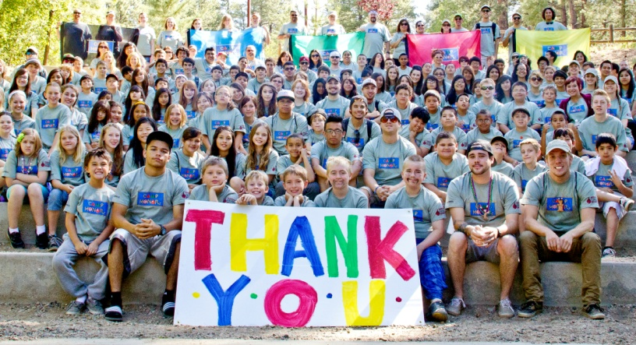

Congratulations!

We couldn’t be more excited to have you as a 2013 Camp HONOR CIT. It’s hard to believe that a little more than a month from now we will be on our way up to the cool pines of Prescott as we work together as a team to celebrate the 20th year of Camp HONOR from June ______.

There is no doubt that without amazing staff members like you, Camp HONOR wouldn’t be impossible. Campers remember their camp staff and counselors as the years pass. A staff member really has the ability to make that one week out the year, the best week for any given camper.

The theme for this year is going to be Homecoming. Come prepared to help us transform Camp Sky-Y into Camp HONOR High as we talk about the legacy we have left behind the past 20 years and explore the idea of “coming home” to a place like camp for years to follow. Costumes, décor, cheering, and spirit are all welcome! Part of the theme will be a traditional homecoming spirit week with: cabin color day, backward day, crazy hair day, mustache day, and camp spirit day.

Please meet at the AHA Office no later than ___________________ for CIT medical check in (parent must be present until you get on the van). All CIT’s must take the designated van and cannot drive themselves to camp.

This year, we are bringing in a camp professional to do fresh training that will expand the skill set of returning staff and orientate new staff.

If you can no longer attend Camp HONOR, please let ________________ know immediately. As of now, we have given you an assignment that would otherwise need to be filled.

Keep in mind all paperwork that may be remaining to complete. All staff members are required to complete the Staff Medical History Form, Staff Consent Form, and the Staff Immunization Form. All of these documents can be located at _______________________________ Please send these forms in immediately to fax _________________ or email _________________________.

If you have any questions or concerns, do not hesitate to call us. We appreciate all of your time and efforts. We will do whatever we can to support you.

With Gratitude:

The Camp HONOR 2013 Committee
