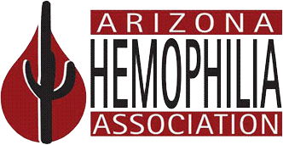

Dear Parents of Future Campers:

We would like to invite you on a tour of Camp HONOR (Hemophiliacs Overcoming New Obstacles Resourcefully) on ____________________! Camp HONOR is designed to allow children with medical needs the opportunity to experience camp activities as well as learn more about their chronic disorder. We are offering you this opportunity to tour the camp site so you may get a feel of camp prior to sending your child to camp in 2014. We understand it may be scary for parents and children to be away from home for 5 days, especially to a place they have never seen before.

We want to make next year’s experience as enjoyable as possible, so are excited to offer you and your child an opportunity to see what camp is all about. We have a fun day planned! We are going to tour the campus, participate in an activity or two, and have lunch with the entire camp.

We are providing transportation to and from camp and will be meeting as a group at the Arizona Hemophilia Association the morning of ________________________. We expect to be back in town by 4 p.m.
Our address is ______________________________.

If you are able to join us, please contact us by _______________________, via phone at ____________________or email ____________________ to reserve your spot. Space is limited so please plan on having only one adult and your child attend. Included, is a signature page containing the guidelines for Visitor’s Day. Please read, sign and bring with you on __________________. Please feel free to call us with any questions.

Hope to hear from you!

Arizona Hemophilia Association

