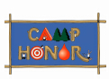
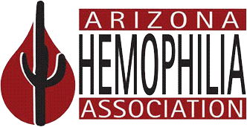

Dear Community Member:

Camp HONOR is fast approaching and we still need a few things from you.

In order to complete the camp application process for ______________________________, we still need the following:

- Camper Medical Form (Needs to be completed by a Licensed Health Care Practitioner)
- Immunization Records
- Tuberculosis Questionnaire
- Camper Code of Honor (Attached and signed by both parent and camper)
- Other:_________________________________________________________________

The deadline to turn in all required paperwork is _________. Failure to submit all items by this date will put your camper on a wait list. Feel free to contact us with any questions or concerns.

Camp Director
123-456-7890

